Tommy Walton

CS 500

Herron

3/16/2015

Project 2: BRDF and BVH

### Project Description

### Metrics

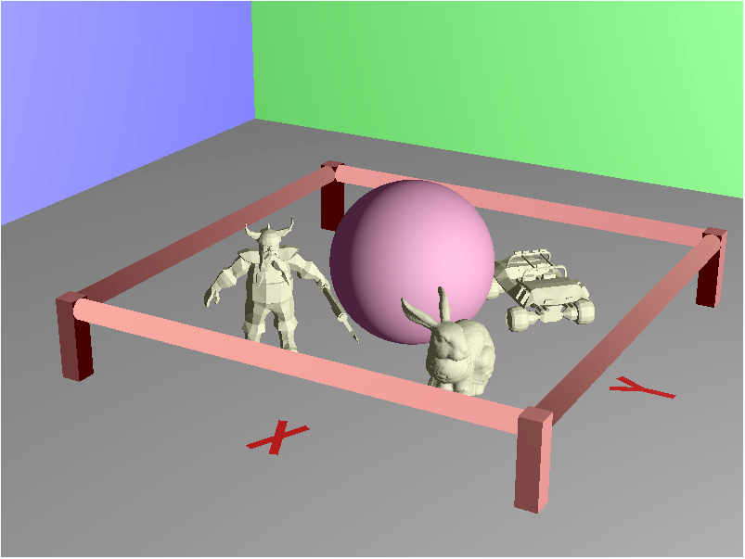

Image Size: 800x600

Contents:

Spheres: 1

Boxes: 7

Cylinders: 4

Triangles: X – 4, Y – 6, Jeep – 2032, Dwarf – 1896, Bunny – 69451 = Total – 73389

Hardware: Surface Pro w/ Intel® Core™ i5-3317U CPU @ 1.70GHz

Time:

Without BVH: 12min, 51.60s

With BVH: